THE DADE COUNTY CIVIL RIGHTS MOVEMENT

GRADE LEVEL: 6-8

LEARNING OBJECTIVES:
Students will learn about key events and people in the Dade County Civil Rights Movement.
Students will identify the causes, forms, and effects of discrimination.
Students will analyze human behavior and historical processes.

FLORIDA STANDARDS:

SS.8. A.5.7 Examine key events and people in Florida history as each impacts this era of American history.

BEST ENGLISH LANGUAGE ARTS STANDARDS:
ELA.8. R.3.2: Paraphrase content from grade-level texts
ELA.8.C.1.4: Write expository texts to explain and analyze information from multiple sources, using relevant supporting details, logical organization, and varied purposeful transitions.
ESSENTIAL QUESTION(s):
- How did religious leaders impact social, political, and economic discrimination in Dade County during the Civil Rights Movement?
- Who is Father John E. Culmer, and how did he contribute to the Civil Rights movement?
- Who is Reverend Theodore R. Gibson, and how did he contribute to the Civil Rights movement?

KEY TERMS: CIVIL RIGHTS MOVEMENT, ACTIVISM, DISCRIMINATION, SEGREGATION, PROTEST, FATHER JOHN E. CULMER, REVEREND THEODORE R. GIBSON

MATERIALS:
ATTACHMENT A: DADE COUNTY CIVIL RIGHTS MOVEMENT PHOTOS
ATTACHMENT B: COMPARISON CHART

ATTACHMENT C: FATHER JOHN E. CULMER READING

TECHNOLOGY

LESSON SEQUENCE:

- LESSON OPENING: Introduce students to the lesson by providing an overview of the Civil Rights Movement. And explain that they will learn how the movement impacted Miami, Florida.
- ACTIVITY: Show students the photos of the various areas of discrimination that Dade County experienced during the Civil Rights Movement ATTACHMENT A.
  - Have students identify what type of discrimination is evident- EX. VOTINGS RIGHTS, HOUSING, SCHOOL, PUBLIC TRANSPORTATION, etc.) Teachers should probe students about their prior knowledge of incidents and ask students to provide evidence from the images.
- ACTIVITY:
  - Have students complete Part I. of the “Comparison Chart” ATTACHMENT B by reading the “Father John E. Culmer (1891-1963)” adapted from Dr. Marvin Dunn’s book, ATTACHMENT C.
  - Teachers should guide students through completing notes, have students work in small groups or independently, implement reading strategies (Chunking, Jigsaw, Annotation, etc.) that will assist students.
  - Have a class discussion about Father John E. Culmer and ensure students completed the chart correctly. Then, students should answer the essential question: Who is Father John E. Culmer, and how did he contribute to the Civil Rights movement?
- ACTIVITY:
  - Have students complete Part II. of the “Comparison Chart” ATTACHMENT B by using technology and accessing the website text “The Reverend Canon Theodore R. Gibson” by Dr. Marvin Dunn. https://dunnhistory.com/the-reverend-canon-theodore-r-gibson/
  - Teachers should guide students through completing notes, have students work in small groups or independently, implement reading strategies (Chunking, Jigsaw, Annotation, etc.) that will assist students.
  - Have student share out their findings of Reverend Theodore R. Gibson. Then, students should answer the essential question: Who is Reverend Theodore R. Gibson, and how did he contribute to the Civil Rights movement?

LESSON CLOSURE/EXIT SLIP: Ask students to create a visual presentation to answer the essential question using the information learned about the two Dade County Civil Rights Leaders. EQ: How did religious leaders impact social, political, and economic discrimination in Dade County during the Civil Rights Movement?

ASSESSMENT: Teacher observation of independent or group work. Evaluation of oral presentation and written product.

TECHNOLOGY
- DR. MARVIN DUNN, Dunn History: A History of Florida Through Black Eyes. https://dunnhistory.com/
- FLORIDA MEMORY, State Library and Archives of Florida: https://www.floridamemory.com/

SUGGESTED READINGS:
Dunn, M. (1997). Part Two: The Barriers Fall, The Dade County Civil Rights Miami, 1944-1970. In Black Miami in the Twentieth Century (pp.171-223). essay, University Press of Florida.

ATTACHMENT A (1-4) Photo #1

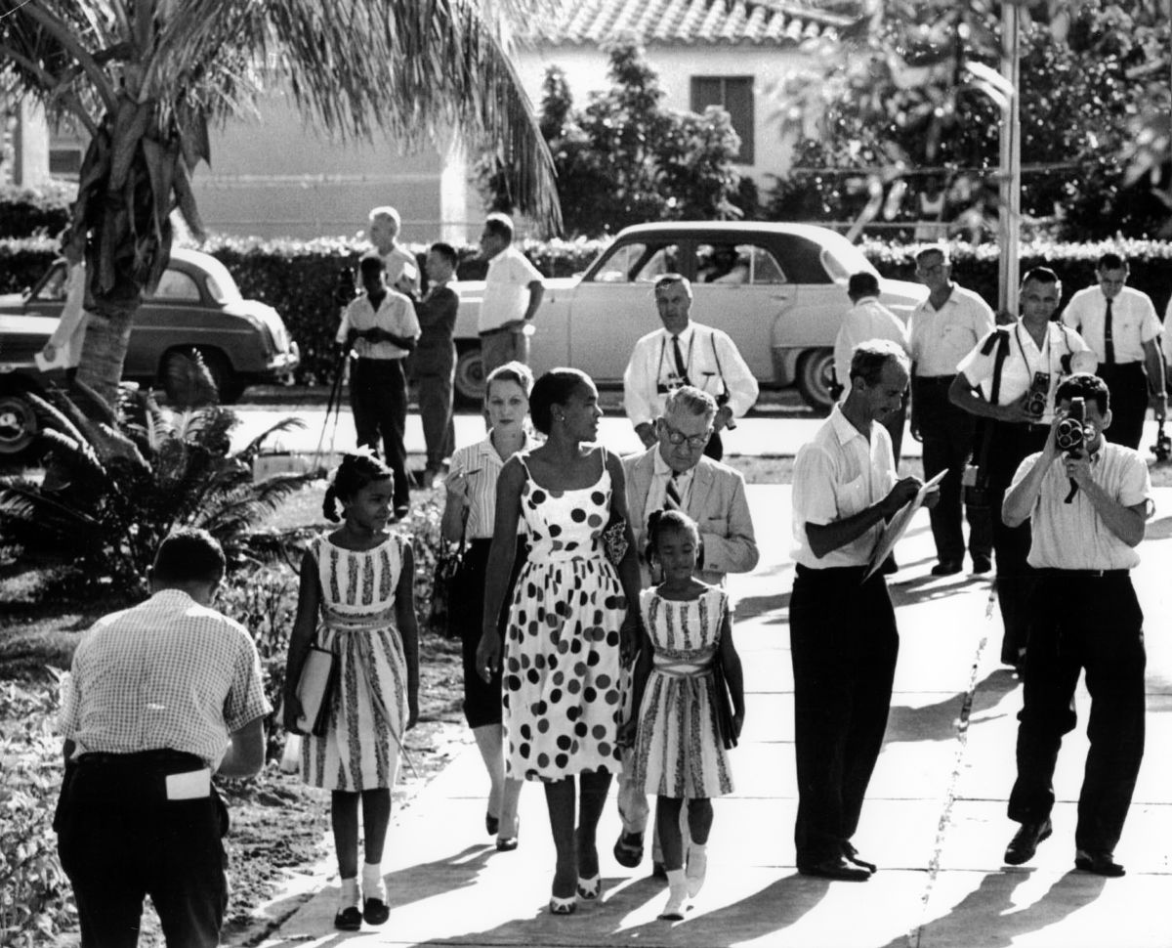

Jan and Irene Glover, ages nine and seven, walk with their mother, Irvena Prymus, to Orchard Villa School in Liberty City, Florida. Prymus was a Congress of Racial Equality (CORE) member.

PHOTO #2

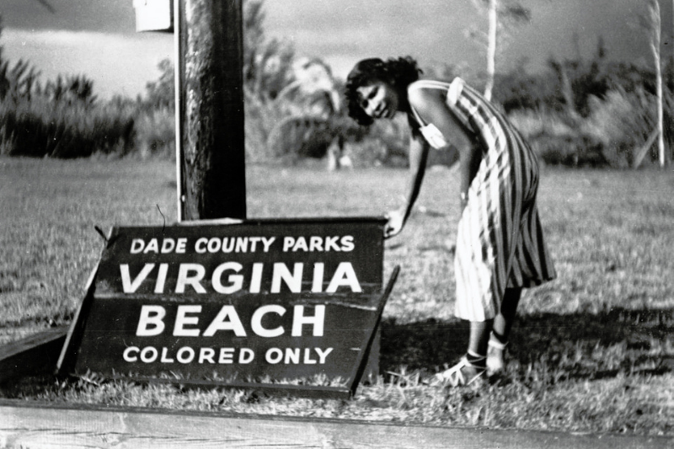

Black Floridians had to contend with the issue of segregation on public beaches.

PHOTO #3
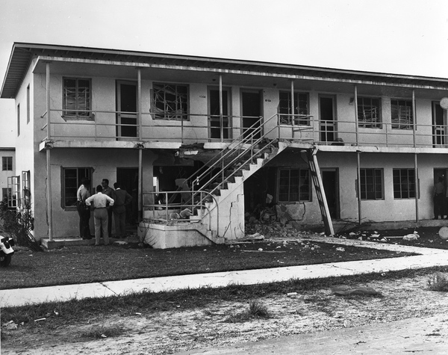
Carver Village bombing, December 5, 1951. The bombing was meant to discourage blacks from moving in.

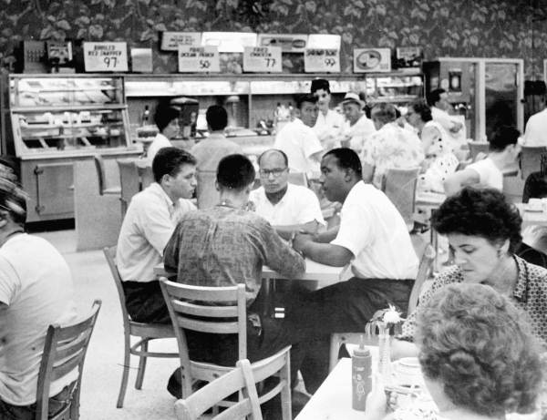
PHOTO #4
Sit-in at a Miami diner, 1960. (State Archives of Florida, Florida Memory)

ATTACHMENT B COMPARISON CHART
CATEGORY | - FATHER JOHN E. CULMER  (1891-1963) | - REVEREND THEODORE R. GIBSON  (1915-1981)
BACKGROUND
EDUCATION
METHOD(S) OF ACTIVISM

(PEACEFUL PROTEST, PASSIVE RESISTANCE, LEGAL CHALLENGES, BOYCOTTS, SPEECHES, LEADERSHIP, MUSIC, ETC.)
CONTRIBUTIONS TO CIVIL RIGHTS MOVEMENT IN DADE COUNTY | Social:  Political:  Economic: | Social:  Political:  Economic:
ATTACHMENT C FATHER JOHN E. CULMER READING

The civil rights period in Dade County predated the civil rights period in other parts of the South by at least a decade. It was led by the activist of the time, Father John E. Culmer of Saint Agnes Episcopal church in Colored Town and later, Reverend Theodore R. Gibson of Christ Church in Coconut Grove.

John Edwin Culmer was born on May 22, 1891to Edwin James and Ellen Spiro Culmer in the Bahamas. His father was a farmer, and his mother a school teacher and seamstress. The Culmer family was educated and musically inclined.

In 1914, Culmer married Nancy Elizabeth Taylor. They lived in Coconut Grove, Florida, until he went to college. In 1916, Culmer obtained a bachelor’s degree in music from Oskaloosa College in Iowa. And later, he earned a Bachelor of Divinity degree from Bishop Payne Divinity School in Petersburg, Virginia.

Father Culmer served as priest of the Saint James Episcopal Church in Tampa, Florida. He gained a reputation as an articulate advocate for minority rights in the black community, while whites saw him as a trustworthy promoter of good relations between the races. By 1930, Father Culmer relocated to Miami, promoting social change between the black and white communities.

In 1934 Father Culmer started a citywide campaign to improve housing for Miami’s blacks. Through columns in the Miami Herald, he exposed the horrifying living conditions in Colored Town. As a result, the mayor appointed him to a committee to study the slum conditions in the city. Ultimately, federal money was allocated to build the Liberty Square Housing Project.

In addition, Father Culmer’s activism in voting rights led to safe voting conditions for blacks in the primary election of 1939. As publicity director of the Interdenominational Miniter’s Alliance, he wrote the chief of police requesting protection for black voters since the Ku Klux Klan embarked upon a campaign to intimidate blacks. Father Culmer’s request was granted, and for the first time, blacks participated in a city election in record numbers.

Father Culmer was Miami’s first prominent black leader and commanded the attention of white media and power structure. Through the national black media, he enjoyed a reputation around the country as Miami’s most articulate black spokesman. He died in 1963.

Dunn, M. (1997). Part Two: The Barriers Fall. In Black Miami In The Twentieth Century (pp. 171-182). essay, University Press of Florida.
Modified for learners, Grades 6-8.

