THE DADE COUNTY CIVIL RIGHTS MOVEMENT

GRADE LEVEL: 9-12

LEARNING OBJECTIVES:
Students will learn about key events and people in the Dade County Civil Rights Movement.
Students will identify the causes, forms, and effects of discrimination.
Students will analyze human behavior and historical processes.

FLORIDA STANDARDS:

SS. 912. A. 1.3: Utilize timelines to identify the time sequence of historical data.
SS. 912. A. 5.7: Examine the freedom movements that advocated civil rights for African Americans, Latinos, Asians, and women.
SS. 912. A. 7.5: Compare nonviolent and violent approaches utilized by groups (African Americans, women, Native Americans, Hispanics) to achieve civil rights.
SS. 912. A. 7.6: Assess key figures and organizations in shaping the Civil Rights Movement and Black Power Movement.

BEST ENGLISH LANGUAGE ARTS STANDARDS:

ELA.12. C.1.2 Write complex narratives using appropriate techniques to establish multiple perspectives and convey universal themes.
ELA.912. R.3.2 Paraphrase content from grade-level texts.

ESSENTIAL QUESTION(s):
- What was the effects of the Civil Rights Movement of Miami?
- Who were some of the major key players of the Civil Right Movement in Miami, FL.? How did they affect change within Miami?
- How did these leaders impact social, political, and economic discrimination in Dade County during the Civil Rights Movement?
- Who is Father M. Athalie Range, and how did she contribute to the Civil Rights movement?
- Who is Reverend Theodore R. Gibson, and how did he contribute to the Civil Rights movement?

KEY TERMS: CIVIL RIGHTS MOVEMENT, ACTIVISM, DISCRIMINATION, SEGREGATION, PROTEST

KEY PEOPLE:
M. Athalie Range, REVEREND THEODORE R. GIBSON

MATERIALS:
COMPOSITION NOTEBOOK
ATTACHMENT A: DADE COUNTY CIVIL RIGHTS MOVEMENT PHOTOS
ATTACHMENT B: COMPARISON CHART

ATTACHMENT C: M. ATHALIE READING

TECHNOLOGY

LESSON SEQUENCE:

- LESSON OPENING: Introduce students to the lesson by providing an overview of the Civil Rights Movement. And explain that they will learn how the movement impacted Miami, Florida.
- ACTIVITY ONE : Play the Audio from Dr. Dunn “The Civil Rights Movement in Miami” https://dunnhistory.com/story-tellers/#civil-rights (14:34 minutes). While listening to the audio from Dr. Dunn, allow students to respond to the following questions based on the audio:
  - With Miami being considered a Tropical Paradise, why would Miami need a Civil Rights Movement?
  - Why was Florida overall hesistent about address it’s race issues?
  - According to the audio why did the “Wade In Take Place”? What was the effect of this protest?
  - Who were some of the major participants in and leaders of the Black Civil Rights Movement in Miami? What were their roles in the Civil Rights Movement of Miami?
  - Who were some of the white individuals that assisted with the Civil Rights Movement of Miami? How did they help move the Miami Civil Rights movement?
- ACTIVITY TWO: Show students the photos of the various areas of discrimination that Dade County experienced during the Civil Rights Movement ATTACHMENT A.
  - Have students identify what type of discrimination is evident- EX. VOTINGS RIGHTS, HOUSING, SCHOOL, PUBLIC TRANSPORTATION, etc.) Teachers should probe students about their prior knowledge of incidents and ask students to provide evidence from the images.
- ACTIVITY THREE:
  - Have students complete Part I. of the “Comparison Chart” ATTACHMENT B by reading the “Father Theodore Gibson (1915-1982)” by Dr. Marvin Dunn. https://dunnhistory.com/the-reverend-canon-theodore-r-gibson/adapted from Dr. Marvin Dunn’s book, ATTACHMENT C.
  - Teachers should guide students through completing notes, have students work in small groups or independently, implement reading strategies (Chunking, Jigsaw, Annotation, etc.) that will assist students.
  - Have a class discussion about Father Theordore R. Gibson and ensure students completed the chart correctly. Then, students should answer the essential question: Who is Father Theodore R. Gibson, and how did he contribute to the Civil Rights movement?
- ACTIVITY:
  - Have students complete Part II. of the “Comparison Chart” ATTACHMENT B by using technology and accessing the website text “M. Althalie Range” adapted from Dr. Marvin Dunn’s book
  - Teachers should guide students through completing notes, have students work in small groups or independently, implement reading strategies (Chunking, Jigsaw, Annotation, etc.) that will assist students.
  - Have student share out their findings of Reverend Theodore R. Gibson. Then, students should answer the essential question: Who is Reverend Theodore R. Gibson, and how did he contribute to the Civil Rights movement?

- LESSON CLOSURE/EXIT SLIP: Ask students to create a visual presentation to answer the essential question using the information learned about the two Dade County Civil Rights Leaders. EQ: How did these leaders impact social, political, and economic discrimination in Dade County during the Civil Rights Movement?

ASSESSMENT: Teacher observation of independent or group work. Evaluation of oral presentation and written product.

TECHNOLOGY
- DR. MARVIN DUNN, Dunn History: A History of Florida Through Black Eyes. https://dunnhistory.com/
- FLORIDA MEMORY, State Library and Archives of Florida: https://www.floridamemory.com/

SUGGESTED READINGS:
Dunn, M. (1997). Part Two: The Barriers Fall, The Dade County Civil Rights Miami, 1944-1970. In Black Miami in the Twentieth Century (pp.171-223). essay, University Press of Florida.

ATTACHMENT A (1-4) Photo #1

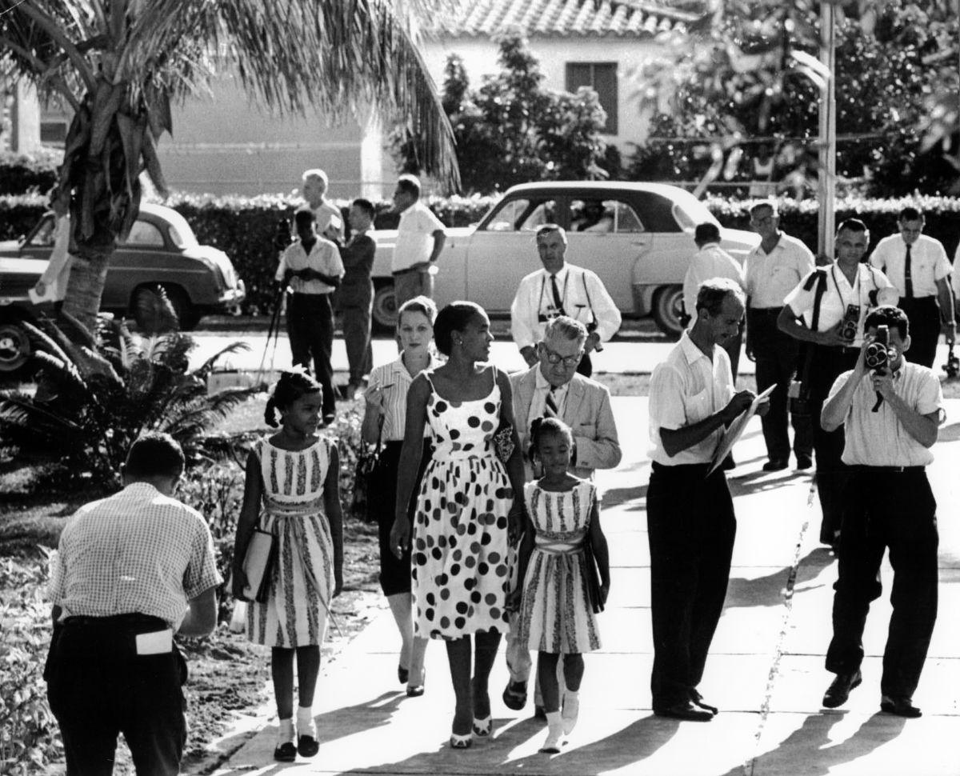

Jan and Irene Glover, ages nine and seven, walk with their mother, Irvena Prymus, to Orchard Villa School in Liberty City, Florida. Prymus was a Congress of Racial Equality (CORE) member. https://dunnhistory.com/media-gallery/

PHOTO #2

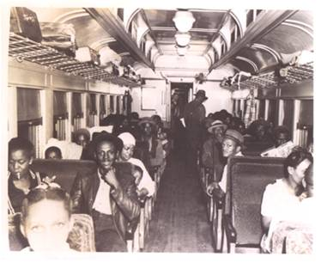
A segregated train coach leaving Miami. https://dunnhistory.com/media-gallery/

PHOTO #3
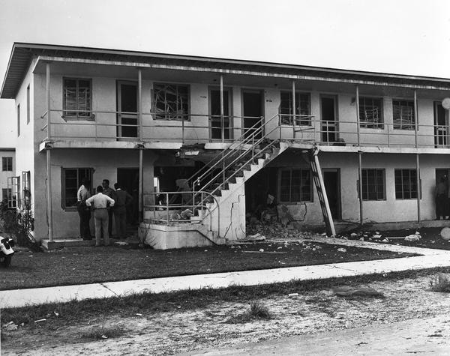
Carver Village bombing, December 5, 1951. The bombing was meant to discourage blacks from moving in.

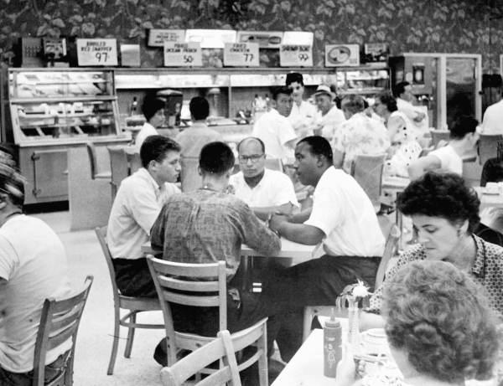
PHOTO #4
Sit-in at a Miami diner, 1960. (State Archives of Florida, Florida Memory)

ATTACHMENT B COMPARISON CHART
CATEGORY | - REVEREND THEODORE R. GIBSON  (1915-1982) | II. M. Athalie Range  (1915-2006)
BACKGROUND
EDUCATION
METHOD(S) OF ACTIVISM

(PEACEFUL PROTEST, PASSIVE RESISTANCE, LEGAL CHALLENGES, BOYCOTTS, SPEECHES, LEADERSHIP, MUSIC, ETC.)
CONTRIBUTIONS TO CIVIL RIGHTS MOVEMENT IN DADE COUNTY | Social:  Political:  Economic: | Social:  Political:  Economic:
ATTACHMENT C The Reverend Canon Theodore R. Gibson 1915 – 1982 READING

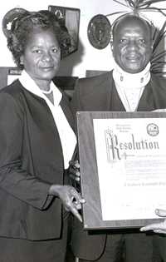

Recognized as a priest, a civil rights demonstrator, and a politician, Theodore Gibson devoted over half of his life to the parish of Christ Episcopal Church in Coconut Grove (Miami), where he served as rector from 1945 until his death in 1982. As a community activist, he is remembered for his commitment to improving the human welfare of Coconut Grove’s African American population.

Born in Miami, Florida in 1915, Theodore Gibson received his bachelor’s degree from St. Augustine’s College in 1938 and his honorary law degree from the same institution in 1964. After graduating from Bishop Payne Divinity School with his Bachelor of Divinity in 1943, he was ordained a deacon that same year and a priest the following year. Before beginning his ministry in Miami, Gibson served as Minister-in-Charge at four parishes in the Diocese of East Carolina and as Priest-in-Charge at St. Cyprian in Hampton, Virginia from 1943 to 1945. While ministering as rector in Coconut Grove, he also served as vicar of St. Cyprian’s Mission in Orlando. He was made an Honorary Canon of what was then the Diocese of Southern Florida (now Southeastern Florida) centered in Orlando.
In 1945 Gibson returned to his native Miami to begin his long-standing commitment as rector to the parishioners of Christ Episcopal Church in Coconut Grove, Miami’s oldest neighborhood and the first black settlement on the South Florida mainland. While in Miami, Gibson exercised his voice and energy as an active proponent of civil rights. During the late 1950s and early 1960s, he filed lawsuits that desegrated the downtown lunch counter, the county beach at Cradon Park, and Dade County public schools.
Theodore Gibson served as president of the Miami chapter of the NAACP from 1954 to 1964. While in that capacity, Gibson was arrested, fined, and sentenced to six months in jail for refusing in 1959 to reveal the names of members of the local NAACP chapter to a Florida state legislative committee (the “Johns Committee” to investigate subversive activity and communist links to American political organizations). In response, the Miami Times published a series of persuasive editorials, which helped fuel church rallies in support of Gibson and fellow African American leader, the Rev. Edward T. Graham. All accusations were cleared in 1963 by the U.S. Supreme Court, effectively putting an end to the McCarthy-inspired search for communist subversives within the Miami chapter of the civil rights organization.
Gibson moved to Miami in1945 to take up work in what was largely a poor community. He immediately recognized the advantage and opportunity of making an ally in the white community to address and improve the many issues facing the African American population living in Coconut Grove. Between 1946 and 1947, He and Elizabeth Virrick (a locally prominent philanthropist) formed the Coconut Grove Citizens Committee for Slum Clearance. Together they were responsible for the transformation of this community, which included the passage of ordinances requiring running water, flushing toilets, septic tanks, as well as sources from which to procure the funds to comply with the regulations. The Committee was also responsible for the creation of many community organizations including a health clinic and day-care center and improved law enforcement by African American policemen. Gibson was appointed a Miami City Commissioner in 1972 and served the community in that capacity until 1981. He was the third African American to serve on the Miami City Commission.
Gibson’s influence extended beyond Coconut Grove. Due to his encouragement, members from African American congregations in Dade and Broward counties in Florida formed the Theodore Gibson Chapter of the Union of Black Episcopalians. Miami Dade College and Miami Dade County Public Schools ventured together to establish the Theodore Gibson Oratorical, Declamation and Advocacy Project. The project is dedicated to providing pre-kindergarten to high school students with the opportunity to develop and improve their public speaking skills through education and competition while exposing them to the wide range of writings about the African American experience. A remark Gibson once made has been adopted as the Project’s theme: “Help the Children to Communicate…That is the Key.” Known as an orator and a visionary who opposed the racist images held by dominant society, he strived to present a black image that challenged stereotypes.
Theodore Gibson was memorialized in his own lifetime as he is by those who have benefitted from his legacy. His name has been given to the parish hall of Christ Church, the local UBE Chapter, to the Miami Dade Community College Gibson Health Center. Gibson Park (at NW 3rd and 12-14 streets) was named in his honor by the city in 1980. In addition to his St. Augustine’s degree, he received an honorary doctor of divinity from Virginia Theological Seminary in 1971. Fr. Gibson married Thelma Vernell Anderson, a former nurse, on April 2, 1967 after the death of his first wife in 1962. Mrs. Gibson continues to work on many of the same civic projects that interest Theodore when they were together.

https://dunnhistory.com/the-reverend-canon-theodore-r-gibson/

Dunn, M. (1997). Part Two: The Barriers Fall. In Black Miami In The Twentieth Century (pp. 171-182). essay, University Press of Florida.
Modified for learners, Grades 9-12.

