Slavery In Miami-Dade County:
The Post Civil War Period (1835 – 1895)

GRADE LEVEL: 9-12

LEARNING OBJECTIVES:
Students will learn about key events and people in Florida's Civil War Period.
Students will identify the causes, forms, and effects of Slavery on Miami-Dade.
Students will learn of the failed attempts of Slavery in Miami-Dade.

FLORIDA STANDARDS:

SS. 912.A.2.1: Review causes and consequences of the Civil War
SS.912. A.3.13 Examine key events and people in Florida history as they relate to United States History.
SS.912. A.1.4: Analyze how images, symbols, objects, cartoons, graphs, charts, maps, and artwork may be used to interpret the significance of time periods and events from the past.
SS.912. A.2.5: Assess how Jim Crow Laws influenced life for African Americans and other racial/ethnic minority groups.

BEST ENGLISH LANGUAGE ARTS STANDARDS:
ELA.12. C.1.2 Write complex narratives using appropriate techniques to establish multiple perspectives and convey universal themes.
ELA.912. R.3.2 Paraphrase content from grade-level texts.
ELA.10. C.4.1: Conduct research to answer a question, refining the scope of the question to align with findings and synthesizing information from multiple reliable and valid sources.
ESSENTIAL QUESTION(s):
- What was the effects of Slavery in Miami-Dade?
- What laws were put in place restraints on black people living in Miami, FL.?
- What was the economic effects of slavery within Miam?
- How successful was slavery in Miami-Dade?

KEY TERMS:
Slavery, Civil War, Slaveholders, Second Seminole War, Colonel Richard R. Fitzpatrick, Slave Quarters, William English, and Fort Dallas

MATERIALS:
COMPOSTION NOTEBOOK

TECHNOLOGY
Attachment A: US Survey Map from 1849 of the Fort Dallas Plantation of Miami, FL.
Attachment B: Analyzing Maps ORQ Chart
Attachment C: Cornell Notetaking Guide
Attachment D: Slavery in Miami Excerpts from Dr. Dunn’s “Black Miami in The Twentieth Century”
Attachment E: Guided Reading Questions

LESSON SEQUENCE:

- LESSON OPENING: Introduce students to the lesson by providing an overview of the history of slavery in the United States. Explain that slavery existed in Miami, Florida, just like it did in other Southern States. Explain that though slavery existed in Miami, Florida, it was not as successful, as it was in many of the other cities in Florida.
- ACTIVITY ONE:
  - ATTACHMENT A. Present students with the image of the US Survey image of the Fort Dallas plantation. Inform students that this was a plantation that was previously owned by Colonel Richard R. Fitzpatrick, a white farmer from South Carolina. Allow students a few moments to analyze the map and its details.
- ACTIVITY TWO:
  - ATTACHMENT B. Distribute the “Analyzing Maps” worksheet to small groups of students Instruct students within their groups to respond to the three columns a. Observe, b. Reflect, and c. Question. Once each group has completed the three columns of the chart, give each group a moment to discuss ways in which they can investigate the map and the information on the map in more detail. Once each group has completed their analyzes, have each group to share their answers in whole group.
- ACTIVITY THREE:
  - ATTACHMENT C: Students will utilize the Cornell Notetaking guide to help guide them in their reading of Dr. Dunn’s “Slavery in Miami” adapted from Dr. Marvin Dunn’s book “Black Miami in the Twentieth Century”.
  - ATTACHMENT D: Students will read the following, Dr. Dunn’s “Slavery in Miami” (pp 27 – 30) reading excerpt from his book “Black Miami in the Twentieth Century”.
  - ATTACHMENT E: After reading the excerpt “Slavery in Miami”. Students will receive a copy of, or the following will be projected for students to respond to… Slavery in Miami Guided Reading Questions - Students will answer questions based on the reading excerpt to test their understanding of the text.
  - Have students share their responses.

- ACTIVITY FOUR:

LESSON CLOSURE/EXIT SLIP: Ask students to answer the essential question: How successful was slavery in Miami-Dade?

ASSESSMENT: Teacher observation of independent or group work. Evaluation of oral presentation and written product.

TECHNOLOGY
- DR. MARVIN DUNN, Dunn History: BLACK MIAMI IN THE TWENTIETH CENTURY. https://dunnhistory.com/
- HIDDEN HISTORY MIAMI: HISTORIC LUMMUS PARK TOURS.
https://hiddenhistorymiami.com/dang-2.html
- FLORIDA MEMORY, State Library and Archives of Florida: https://www.floridamemory.com/
SUGGESTED READINGS:
Dunn, M. (2016). Blacks In Early South Florida (1649 - 1895). In BLACK MIAMI IN THE TWENTIETH CENTURY (pp. 1 – 30). University Press of Florida

ATTACHMENT A:
US Survey Map from early in 1849 of the Fort Dallas Plantation
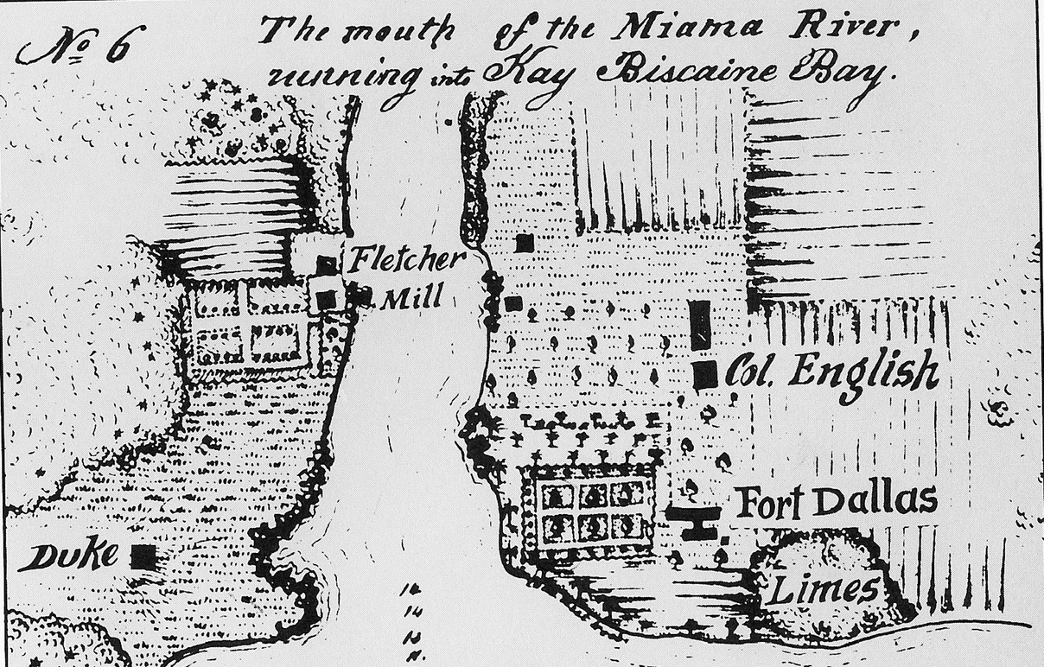

ATTACHMENT B:
Analyzing Maps: ORQ
OBSERVE | REFLECT | QUESTION
Describe what you see. · What do you notice first? · What size and shape is the map? · What graphical elements do you see? · What on the map looks strange or unfamiliar? · Describe anything that looks like it does not belong on a map. · What place or places does the map show? · What, if any, words do you see? | Why do you think this map was made? · Who do you think the audience was for this map? · How do you think this map was made? · How does it compare to current maps of this place? · What does this map tell you about what the people who made it knew and what they didn’t? · If this map was made today, what would be different? · What would be the same? | What do you wonder about... who? · What? · When? · Where? · Why? · How?
Investigate Further: What more do you want to know, and how can you find out more?

ATTACHMENT C:
CORNELL NOTE TAKING GUIDE
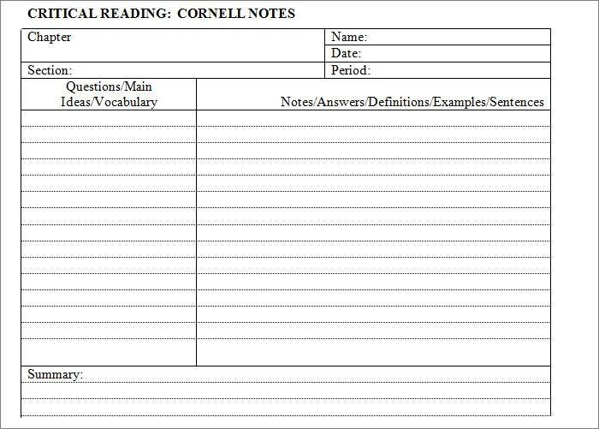

ATTACHMENT D:
SLAVERY IN MIAMI READING EXCERPT

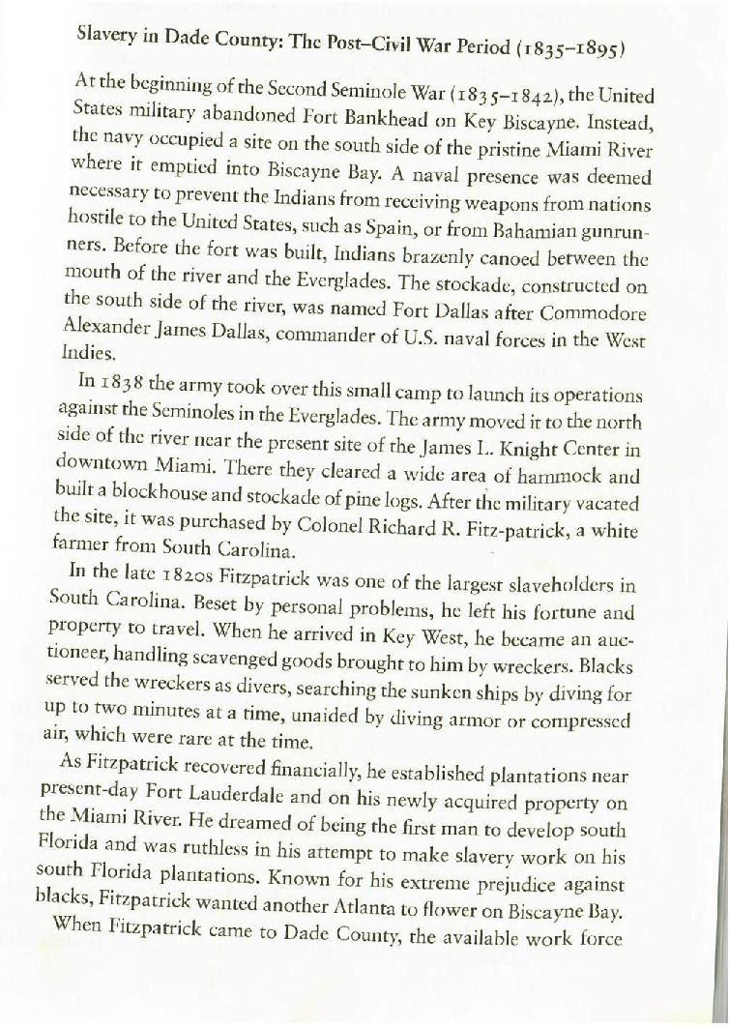

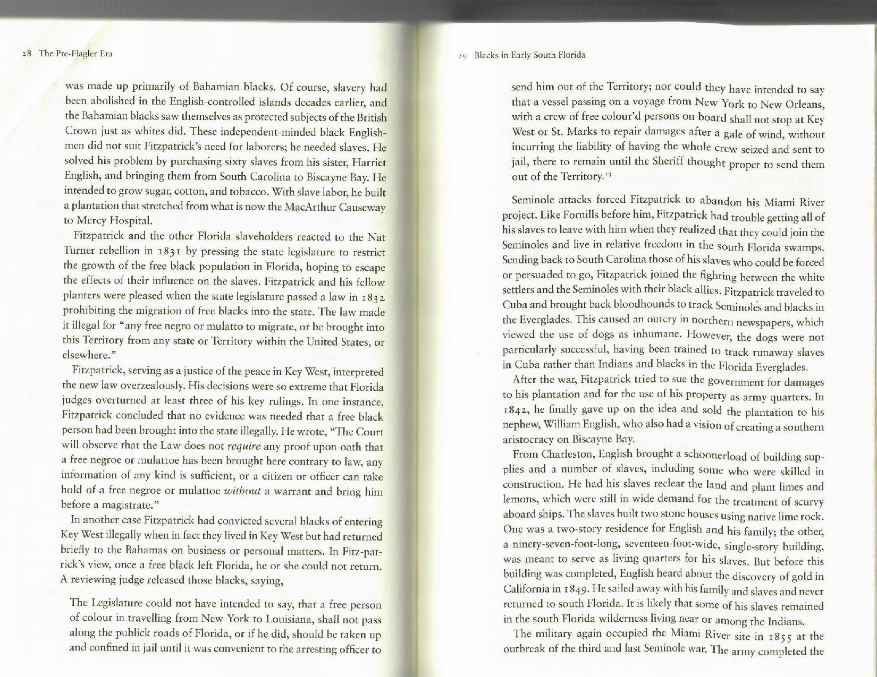

ATTACHMENT E:
GUIDED READING QUESTIONS

- According to the text, why was Colonel Richard R. Fitzpatrick not successful at his first attempt to introduce slavery to Miami?
- What were the cash crops that Colonel Richard R. Fitzpatrick intended to introduce to Miami’s slave industry?
- How did Colonel Fitzpatrick acquire most of his slaves for his plantation?
- What was the law that was introduced in the State of Florida in 1832? Why was this law established?
- What were some issues with the law that was passed in 1832?
- According to the text, why was Colonel Richard Fitzpatrick unsuccessful at making slavery in Miami successful?
- According to the text who was William English? What role did he play at the Fort Dallas plantation?

