MIAMI: RIOTS OF THE 1980S

GRADE LEVEL: 6-8

LEARNING OBJECTIVES:
Students will learn about the 1980s riots in Miami, Florida.
Students will identify the causes and consequences of the Miami riots.
Students will identify the causes, forms, and effects of discrimination.
Students will analyze human behavior and historical processes.

FLORIDA STANDARDS:

SS.8. A.5.7 Examine key events and people in Florida history as each impacts this era of American history.

BEST ENGLISH LANGUAGE ARTS STANDARDS:
ELA.8. R.3.2: Paraphrase content from grade-level texts
ELA.8.C.1.4: Write expository texts to explain and analyze information from multiple sources, using relevant supporting details, logical organization, and varied purposeful transitions.
ESSENTIAL QUESTION(s):
- What is a riot? Why do riots occur?
- What were the economic, political, and social causes and consequences of the 1980s riots in Miami?

KEY TERMS: RIOT, POLICE BRUTALITY, CIVIL DISOBEDIENCE, ARTHUR MCDUFFIE, NEVEL JOHNSON, CLEMENT ANTHONY LLOYD, ALLAN BLANCHARD

MATERIALS:
ATTACHMENT A: STUDENT WORKSHEET
ATTACHMENT B: ARTICLE

ATTACHMENT C: 1980S RIOT IMAGES
ATTACHMENT D: THE NEVEL JOHNSON INCIDENT 1982-READING
ATTACHMENT E: THE LOZANO INCIDENT 1989-READING

TECHNOLOGY

LESSON SEQUENCE:

IMPORTANT: Teachers should be cautious with addressing this topic. Develop a class contract with students and inform them that their learning environment is a safe space. Should they feel uncomfortable with today’s topic, allow students to be excused from the discussion. Provide time to reflect and connect with emotions by journaling privately. See “Contracting” strategy by FHAO. https://www.facinghistory.org/resource-library/teaching-strategies/contracting

- LESSON OPENING: Introduce students to the lesson by projecting or writing the word “RIOT” on the board.
  - Ask students to provide the meaning of the word “riot.” Then, ask students to activate prior knowledge and tell what they know about riots? This discussion should unveil the causes and impact of riots.
  - Tell students they will learn about the 1980s riots in Miami, Florida.
- ACTIVITY:
  - Give students access to “Student Worksheet” ATTACHMENT A.
  - Review the worksheet and explain expectations. The activities can be incorporated into whole groups and in individual sections.
  - Have students read “Overview” to get the jest of each incident.
  - Then, complete section II of the Student Worksheet using ATTACHMENTS B &C and technology to access the website to read “The Miami Riot of 1980: the Killing and Trial by Dr. Marvin Dunn https://dunnhistory.com/the-miami-riot-of-1980-by-marvin-dunn/. Students will read the section entitled “The Killing” only.
  - Teachers should review the materials before the lesson to ensure appropriateness for learners.
  - Discuss responses with students.
- ACTIVITY:
  - Have students complete sections III and IV by reading ATTACHMENTS D & E. Students can work in small groups or independently, implementing reading strategies (Chunking, Jigsaw, Annotation, etc.) to assist students.
  - Discuss responses with students.
LESSON CLOSURE/EXIT SLIP: Ask students to consider what they have learned about the three riots. Respond to the question: What were the causes and consequences of the 1980s riots in Miami?

ASSESSMENT: Teacher observation of independent or group work. Evaluation of oral presentation and written product.

TECHNOLOGY
- DR. MARVIN DUNN, Dunn History: A History of Florida Through Black Eyes. https://dunnhistory.com/
- FLORIDA MEMORY, State Library and Archives of Florida: https://www.floridamemory.com/

SUGGESTED READINGS:
Dunn, M. (1997). Part Three: Race Riots and Civil Disturbances (1968-1995), Riots of the 1980s. In Black Miami in the Twentieth Century (pp.267-314). essay, University Press of Florida.

ATTACHMENT A STUDENT WORKSHEET

- OVERVIEW| Read the summary of incidents that lead to the Miami Riots in the 1980s.
1979 | Miami, FL | Arthur McDuffie was handcuffed for a traffic violation and beaten to death by Dade County police officers.
1982 | Miami, FL | A Miami police officer shot Nevel Johnson at an arcade in Overtown. It was alleged that the officer saw a gun on Nevel, but it was never found upon investigation.
1989 | Miami, Fl | Police officer shot motorcyclist, Clement Lloyd during a chase and sequentially, Lloyd and his passenger died.

- THE MCDUFFIE INCIDENT (1979)
- RESOURCE| “The Miami Riot of 1980: the Killing and Trial” By Dr. Marvin Dunn| https://dunnhistory.com/the-miami-riot-of-1980-by-marvin-dunn/
READ| Section “The Killing”|
- What happened?
- What surprised you about events that led to the incident?
- What social and economic challenges were experienced by blacks in Miami during the mid-1970s?

- RESOURCE| ARTICLE (ATTACHMENT B )

- Based on the title, Infer what the verdict was in the trial?
- Read “ McDuffie Decision Brings Dismay, Disbelief, Anger”
- According to the article, how did Miamians react to the verdict? Provide evidence.
- What surprised you about the article?

- RESOURCE| RIOT IMAGES (ATTACHMENT C)
  - What surprised you about the images?
  - What do these images make you wonder? What broader questions do these images raise for you?
  - What were the consequences of the riot?

- THE NEVEL JOHNSON INCIDENT (1982)
- RESOURCE| READING TEXT (ATTACHMENT D)
  - What surprised you about the incident?
  - What broader questions does this incident raise for you?

- THE 1989 RIOT
- RESOURCE| READING TEXT (ATTACHMENT E)
  - What surprised you about the incident?
  - What broader questions does this incident raise for you?

- SYNTHESIS: Consider what you have learned about the three riots. Respond to the question: What were the causes and consequences of the 1980s riots in Miami?

ATTACHMENT B ARTICLE

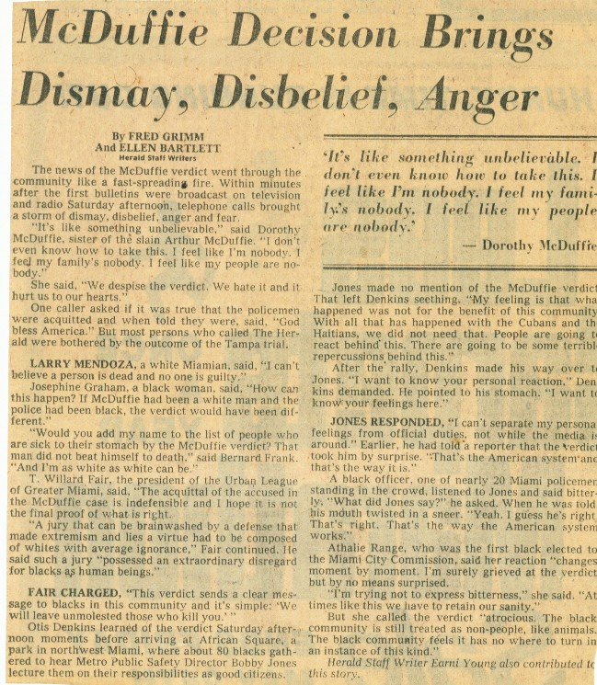

ATTACHMENT C RIOT IMAGES

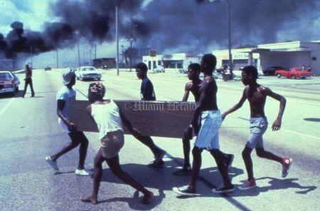
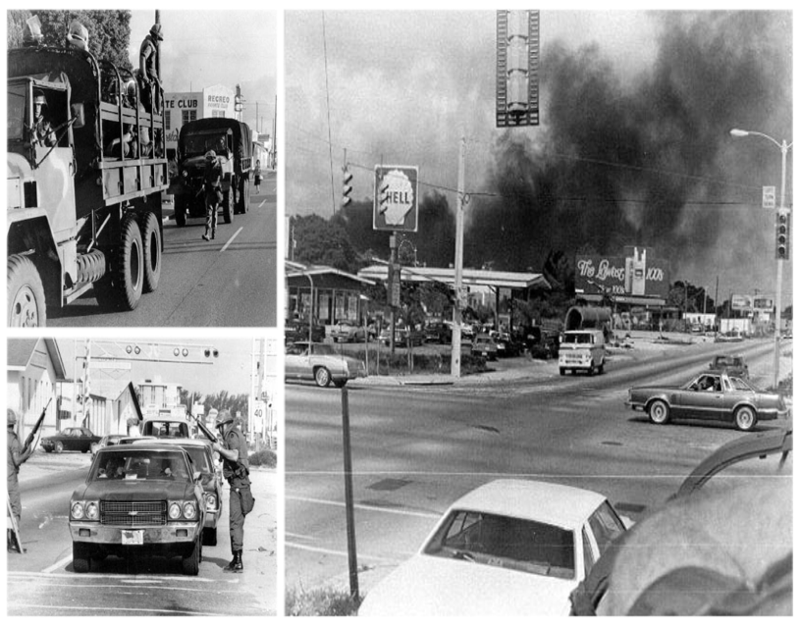
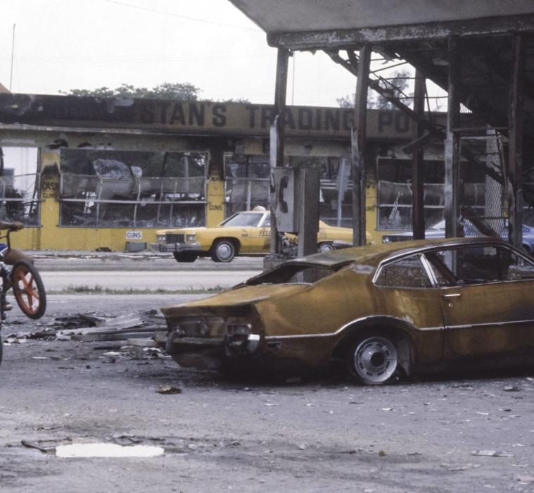
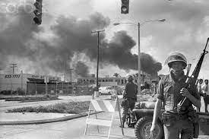
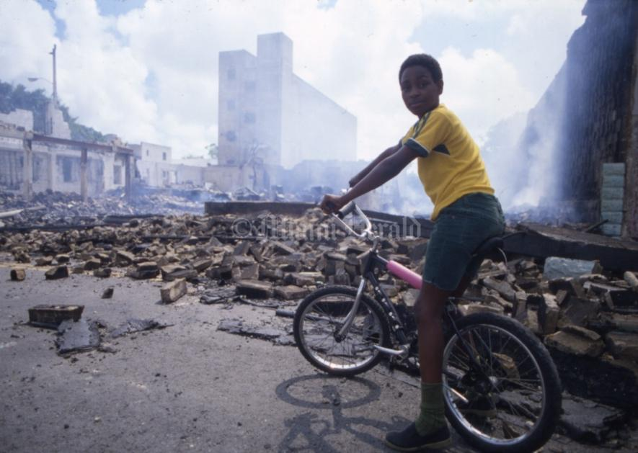
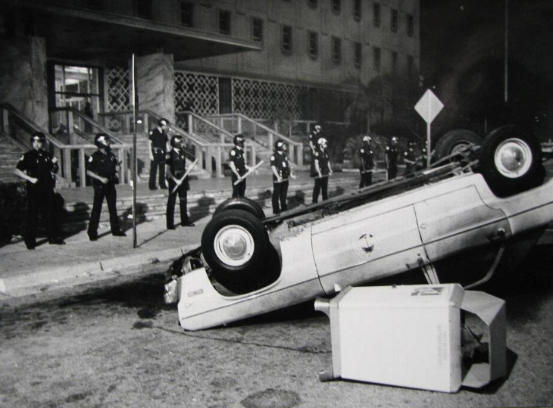

ATTACHMENT D THE NEVEL JOHNSON INCIDENT (1982)

On December 28, 1982, Nevel Johnson Jr., a twenty-year-old black male, was playing a video game at a popular local recreation establishment in Overtown. Two uniformed officers entered the game room, and shortly afterward, a shot was fired, and Johnson lay motionless on the floor.

An officer noticed what appeared to be a gun under Johnson’s clothing. The officer placed his left hand on the bulge and drew his weapon with his right hand. Several witnesses at the scene had different versions of what happened. Some stated Johnson was not armed, and others claim he did. Nevertheless, all agreed Johnson was shot without provocation and without making a threatening movement. More importantly, the gun was never located when homicide investigators arrived.

Immediately after the shooting, Overtown erupted into a riot. Police cruisers were set ablaze, shot at, and stores were looted. The video arcade employees kept back the angry crowd to protect the establishment and the officers trapped inside.

Meanwhile, members of the Ku Klux Klan gathered on Brickell Avenue and Southeast Twenty-fifth road to pass out literature supporting the police and advocating the rights of white people. Community activists argue that what happened to Johnson and the rioting was predictable given the economic and social conditions in the city.

The officers' trial began on January 18, 1984, to an all-white jury, including five non-Hispanic whites and one Hispanic. The trial lasted nearly two months; it took the jury only two hours to reach a verdict of not guilty. Immediately after the verdict, outbursts of violence and looting reoccurred.

In 1984, Miami city commissioners approved a $460,000 settlement with Johnson’s parents. The settlement, part in cash and part annuity, brought the family amount $1.1 million.

Dunn, M. (1997). Part Three: Race Riots and Civil Disturbances (1968-1995). In Black Miami In The Twentieth Century (pp. 299-304). essay, University Press of Florida.
Modified for learners, Grades 6-8.

ATTACHMENT E THE LOZANO INCIDENT (1989)

On January 16, 1989, Officer Lozano and his partner were handling a domestic dispute at an apartment near Northwest Third Avenue and Sixteenth Street. He radio a nearby police cruiser for assistance with a report when Lozano heard about a chase, and then heard the roaring of a motorcycle driving by Clement Lloyd coming his way. Seconds later, Lozano stepped into the street with weapon drawn and fatally shot Lloyd and seriously injured his passenger, Allan Blanchard, who died the next day.

Soon after the motorcycle crashed, a crowd of about two hundred residents took to the streets throwing rocks and bottles at police officers. By night, a caravan of police cruisers circled the area, carrying officers with guns pointed out of the back doors in an effort to discourage rioters. Nevertheless, looting began and fires set.

Violence spread from Overtown into Liberty City and Coconut Grove as Miami entered its second night of rioting.

The violence started to wind down on January 20, 1989. The disturbances left one dead, 11 injured, and 372 arrested. At least thirteen buildings were burned and damages were estimated at $1 million.

Officer Lozano was charged with two counts of manslaughter with a firearm and found guilty on December 7, 1989. Lozano appealed the verdict and was retired. In May 1993, he was found not guilty.

In April 1991, the City of Miami agreed to pay $500,000 each to the families of Clement Lloyd and Allan Blanchard. Under the agreement, the city acknowledges no legal responsibility for the deaths. The structured settlement included a cash payment with the balance in an annuity.

As a result of the 1980s rioting, Metro-Dade and Miami police increased the percentage of black officers on the force. A team police program was established to patrol Dade’s housing projects, and mini-precincts were built in Liberty City and Overtown. As the forces became more reflective of the community’s diversity, the public complained less about police misconduct.

Dunn, M. (1997). Part Three: Race Riots and Civil Disturbances (1968-1995). In Black Miami In The Twentieth Century (pp. 299-304). essay, University Press of Florida.
Modified for learners, Grades 6-8.

