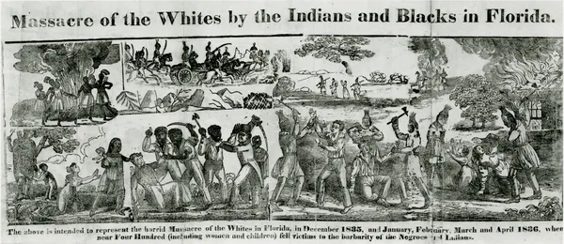
HISTORY IN A FLASH:
DADE MASSACRE, 1835

GRADE LEVELS: 6-8

LEARNING OBJECTIVES:

- Students will identify the causes and consequences of the Dade Massacre in 1835.
- Students will identify key people that participated in the Dade Massacre.
- Students will evaluate whether the battle was justifiable.

FLORIDA STANDARDS:

SS. 8.A.1.2 Use research and inquiry skills to analyze American history using primary and secondary sources.
SS.8. A.4.2 Describe the debate surrounding the spread of slavery into western territories and Florida.
SS.8. A.4.3 Examine the experiences and perspectives of significant individuals and groups during this era of America History.
SS.8. A.4.4 Discuss the impact of westward expansion on cultural practices and migration patterns of Native American and African slave populations.
SS.8.4.17 Examine key events and peoples in Florida history as each impacts this era of American history.

B.E.S.T ENGLISH LANGUAGE ART STANDARDS:
ELA.8.R.3.2: Paraphrase content from grade-level texts.
ESSENTIAL QUESTIONS:
- What were the causes of the Dade Massacre in1835?
- What happened during the Dade Massacre in 1835? Were participants justified in their actions?

KEY TERMS:
SEMINOLES, BLACK SEMINOLES, SEMINOLES WARS, MAJOR FRANCIS DADE, DADE MASSACRE,

MATERIALS:
ATTACHMENT A STORY MAPPING: HISTORY FRAME” graphic organizer
YOUTUBE VIDEO: DADE MASSACRE: THE SECOND SEMINOLE INDAN WAR” https://youtu.be/aZY_ZHzFZp4
TECHNOLOGY
LESSON SEQUENCE:
- LESSON OPENING: Introduce students to the topic of the Dade massacre by explaining that in the early 1800s, America was expanding its political system and governance over territories. As American settlement spread to the West, they came into conflict with the Native Americans who lived on the lands. During the Jackson era, Native Americans were forced to abandon their land, but the Florida Seminoles resisted resettlement with the help of Black Seminoles. Today, you will learn about the Dade Massacre and how Native Americans and the Black Seminoles oppose resettlement.

- ACTIVITY:
  - Have students watch “DADE MASSACRE: THE SECOND SEMINOLE INDAN WAR” (YOUTUBE VIDEO) https://youtu.be/aZY_ZHzFZp4
  - Ask students why this event was called the “Dade Massacre”? Did they know that Dade County was named after Major Francis Dade?

- ACTIVITY:
  - Have students complete the “STORY MAPPING: HISTORY FRAME” graphic organizer ATTACHMENT A using technology to access the website to read Dr. Dunn’s “The Alliance of Blacks and Seminoles” reading https://dunnhistory.com/the-alliance-of-blacks-and-seminoles-by-dr-marvin-dunn/
  - Teachers should guide students through completing the worksheet have students work in small groups or independently. Incorporate reading strategies to accommodate students’ reading level (Chunking, Jigsaw, Cornel Note-Taking, Sketch to Stretch.)
  - Review and discuss students’ responses to the graphic organizer as a class.

LESSON CLOSURE/EXIT SLIP: Ask students consider what you have learned about the Dade Massacre. Respond to the questions: Was the battle justifiable? Do you believe it was a good idea to name a county of Florida after Major Dade? Why or why not?
ASSESSMENT: Teacher observation of independent or group work. Evaluation of oral presentation and written product.

TECHNOLOGY
- DR. MARVIN DUNN, Dunn History: A History of Florida Through Black Eyes. https://dunnhistory.com/
- YOUTUBE: DADE MASSACRE-THE SECOND SEMINOLE WAR https://youtu.be/aZY_ZHzFZp4

SUGGESTED READINGS:
Dunn, M. (1997). Part One: The Pre-Flagler Era, Blacks in Early South Florida, In Black Miami in the Twentieth Century (pp.22-24.) essay, University Press of Florida.

ATTACHMENT A HISTORY FRAME GRAPHIC ORGANIZER



