FLORIDA'S CIVIL RIGHTS MOVEMENT: TALLAHASSEE AND ST. AUGUSTINE

GRADE LEVEL: 6-8

LEARNING OBJECTIVES:
Students will learn about key events and people in Florida's Civil Rights Movement.
Students will identify the causes, forms, and effects of discrimination.
Students will analyze human behavior and historical processes.

FLORIDA STANDARDS:

SS.8. A.5.7 Examine key events and people in Florida history as each impacts this era of American history.

BEST ENGLISH LANGUAGE ARTS STANDARDS:
ELA.8. R.3.2: Paraphrase content from grade-level texts
ELA.8.C.1.4: Write expository texts to explain and analyze information from multiple sources, using relevant supporting details, logical organization, and varied purposeful transitions.
ESSENTIAL QUESTION(s):
- What significant events occurred in Tallahassee and St. Augustine during the Civil Rights Movement?
- How did these events impact people in Tallahassee and St. Augustine during the Civil Rights Movement? How did it affect the government?
- What organizations shaped the events in Tallahassee and St. Augustine during Florida's Civil Rights Movement?

KEY TERMS: TALLAHASSEE BUS BOYCOTT, SIT-INS, REVEREND CHARLES KENZIE STEELE, NAACP, PATRICIA STEPHENS, CONGRESS OF RACIAL EQUALITY-CORE, NON-VIOLENT PROTEST, FLORIDA A&M UNIVERSITY, MONSON MOTOR LODGE PROTEST, DR. MARTIN LUTHER KING, SOUTHERN CHRISTIAN LEADERSHIP CONFERENCE-SCLC.

MATERIALS:
ATTACHMENT A: KEY TERMS SORT
ATTACHMENT B: TALLAHASSEE BUS BOYCOTT & ST. AUGUSTINE SWIM-IN IMAGES

ATTACHMENT C: TALLAHASSEE CIVIL RIGHTS MOVEMENT QUESTIONS (AUDIO)

TECHNOLOGY

LESSON SEQUENCE:

- LESSON OPENING: Introduce students to the lesson by providing an overview of the Civil Rights Movement. Explain that in Florida, the civil rights struggle commenced in the 1940s. During Florida's movement, voting rights, black access to public facilities, jobs, and anti-lynching efforts were primarily addressed by implementing non-violent tactics with support from organizations. Most of the civil rights demonstrations in Florida took place in two cities, Tallahassee and St. Augustine.
- ACTIVITY: Distribute key terms to small groups of students ATTACHMENT A. Have students cut out each key term? Instruct students to "sort" the words into three categories: ORGANIZATIONS, EVENTS, PEOPLE. Ask a group to share.
- ACTIVITY:
  - Project the "TALLAHASSEE BUS BOYCOTT" demonstration image ATTACHMENT B. Lead students through a verbal analysis.
    - Ask students to look deeply at the image, observing people, objects, etc.
    - Have students write down what they see without making any interpretation of the picture.
    - Ask students: What questions do you have about this picture that you would need to have answered before interpreting.
    - Have students discuss questions with peers.
    - Ask students what they think the photographer's perspective, who is the intended audience.
    - Discuss the historical event with students
  - Now, have students answer questions ATTACHMENT C by playing the "Tallahassee Civil Rights Movement" recording to the class. (Access recording by clicking the link: play until 4:21 minutes.) https://dunnhistory.com/story-tellers/#tallahassee-civil-cights-movement
  - Have students share their responses.

- ACTIVITY:
  - Project "ST. AUGUSTINE, SWIN-IN" image from ATTACHMENT B
    - Ask students to look deeply at the photo, observing people, objects, etc.
    - Have students write down what they see without making any interpretation of the picture.
    - Ask students: What questions do you have about this picture that you would need to have answered before interpreting.
    - Have students discuss questions with peers.
    - Ask students what they think the photographer's perspective, who is the intended audience.
    - Discuss the historical event with students.
  - Have students research the Civil Rights movement in St. Augustine, Florida, using technology and determine whether or not it was a success.

LESSON CLOSURE/EXIT SLIP: Ask students to answer the essential question: What significant events occurred in Tallahassee and St. Augustine during the Civil Rights Movement?

ASSESSMENT: Teacher observation of independent or group work. Evaluation of oral presentation and written product.

TECHNOLOGY
- DR. MARVIN DUNN, Dunn History: A History of Florida Through Black Eyes. https://dunnhistory.com/
- FLORIDA MEMORY, State Library and Archives of Florida: https://www.floridamemory.com/
- FACING HISTORY AND OURSELVES: TEACHING STRATEGIES https://www.facinghistory.org/resource-library/teaching-strategies/analyzing-images
- NPR.ORG: Staff, N. P. R. (2014, June 13). Remembering a civil rights swim-in:, 'it was a milestone. NPR. Retrieved March 10, 2022, from https://www.npr.org/2014/06/13/321380585/remembering-a-civil-rights-swim-in-it-was-a-milestone

SUGGESTED READINGS:
Dunn, M. (2016). Jim Crow and the Civil Rights Movement. In A History of Florida: Through Black Eyes (pp. 183–191). essay, CreateSpace Independent Publishing Platform.

ATTACHMENT A KEY TERMS SORT

TALLAHASSEE BUS BOYCOTT
SIT-INS
REVEREND CHARLES KENZIE STEELE NAACP
PATRICIA STEPHENS
CONGRESS OF RACIAL EQUALITY (CORE)
NON-VIOLENT PROTEST
FLORIDA A&M UNIVERSITY
MONSON MOTOR LODGE PROTEST
DR. MARTIN LUTHER KING
SOUTHERN CHRISTIAN LEADERSHIP CONFERENCE (SCLC)
WILHELMINA JAKES

CARRIE PATTERSON

ATTACHMENT B PHOTO #1

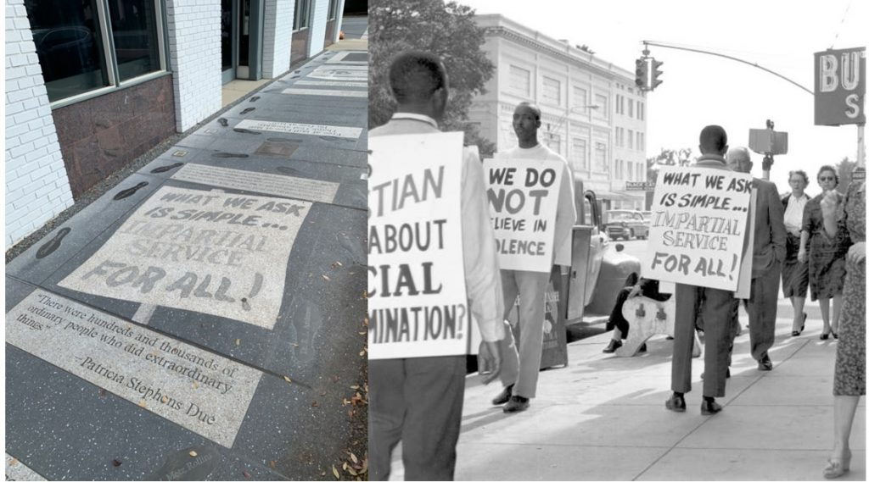

ATTACHMENT B PHOTO #2

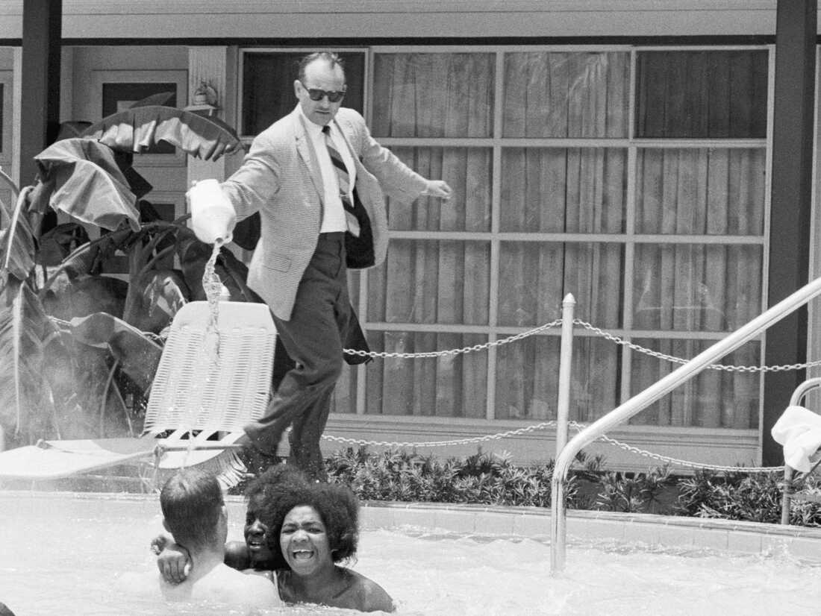

ATTACHMENT C TALLAHASSEE CIVIL RIGHTS MOVEMENT QUESTIONS (AUDIO)

SOURCE: https://dunnhistory.com/story-tellers/#tallahassee-civil-cights-movement
LISTEN: Time 0:00-4:21 mins.

- In what year did the Tallahassee Civil Rights Movement start?

- Who led the Tallahassee Civil Rights Movement?

- What is the capital of Florida?

- What colleges are located in Tallahassee, Florida?

- Why is Patricia Stephen considered an "unsung hero"?

- Who were the Tallahassee 11?

