FLORIDA'S CIVIL RIGHTS MOVEMENT:
TALLAHASSEE AND ST. AUGUSTINE

GRADE LEVEL: 9-12

LEARNING OBJECTIVES:
Students will learn about key events and people in Florida's Civil Rights Movement.
Students will identify the causes, forms, and effects of discrimination.
Students will analyze human behavior and historical processes.

FLORIDA STANDARDS:

SS.912. A.3.13 Examine key events and people in Florida history as they relate to United States History.
SS.912.A.1.4: Analyze how images, symbols, objects, cartoons, graphs, charts, maps, and artwork may be used to interpret the significance of time periods and events from the past.
SS.912.A.7.5: Compare nonviolent and violent approaches utilized by groups (African Americans, women, Native Americans, Hispanics) to achieve civil rights.
SS.912.A.7.6: Assess key figures and organizations in shaping the Civil Rights Movement and Black Power Movement.

BEST ENGLISH LANGUAGE ARTS STANDARDS:
ELA.12.C.1.2 Write complex narratives using appropriate techniques to establish multiple perspectives and convey universal themes.
ELA.912.R.3.2 Paraphrase content from grade-level texts.
ESSENTIAL QUESTION(s):
- What significant events occurred in Tallahassee and St. Augustine during the Civil Rights Movement?
- How did these events impact people in Tallahassee and St. Augustine during the Civil Rights Movement? What changes were made in Florida government?
- What organizations shaped the events in Tallahassee and St. Augustine during Florida's Civil Rights Movement?
- How did local college students effect change during the Civil Rights Movement?

KEY TERMS:
FLORIDA A&M UNIVERSITY (FAMU), TALLAHASSEE BUS BOYCOTT, SIT-INS, NAACP, INTER-CIVIC COUNCIL (ICC), CONGRESS OF RACIAL EQUALITY (CORE), NON-VIOLENT PROTEST, SOUTHERN CHRISTIAN LEADERSHIP CONFERENCE (SCLC)

KEY PEOPLE:
REVEREND CHARLES KENZIE STEELE, PATRICIA STEPHENS, WILHELMINA JAKES, CARRIE PATTERSON & DR. MARTIN LUTHER KING

MATERIALS:
COMPOSTION NOTEBOOK
ATTACHEMENT A: REV. C.K. STEELE QUOTE IMAGE
ATTACHMENT B: KEY TERM FRENZY
ATTACHMENT C: TALLAHASSEE BUS BOYCOTT & ST. AUGUSTINE SWIM-IN IMAGES

ATTACHMENT D: TALLAHASSEE CIVIL RIGHTS MOVEMENT QUESTIONS (AUDIO)

TECHNOLOGY

LESSON SEQUENCE:

- LESSON OPENING: Introduce students to the lesson by providing an overview of the Civil Rights Movement. Explain that in Florida, the civil rights struggle commenced in the 1940s. During Florida's movement, voting rights, black access to public facilities, jobs, and anti-lynching efforts were primarily addressed by implementing non-violent tactics with support from organizations. Most of the civil rights demonstrations in Florida took place in two cities, Tallahassee and St. Augustine.
- QIUCK WRITE ACTIVITY: Present students with a photo image of the quote from Reverand Charles Keenze Steele ATTACHMENT A. Once the image has been presented, read the quote allowed with the students, and then allow students a few moments to analyze the quote for themselves. After about two minutes , allow students the opportunity to write in the composition books, from their own perspective, What do they think Rev. C.K. Steele was implying by this quote. Allow students to shareout their ideas.
- ACTIVITY ONE:
  - Allow students a few moments to define the key terms associated with the lesson
  - ATTACHMENT B: Distribute key terms and images to small groups of students. Instruct students within their groups to match key terms with the matching image that’s associated with the terms. Secondly, instruct students to "sort" the words into three categories: ORGANIZATIONS, EVENTS, PEOPLE. Then have each group to share and explain, the reasoning behind why their group placed the words in those categories.

- ACTIVITY TWO:
  - Project the "TALLAHASSEE WOOLSWORTH SIT-IN" demonstration image ATTACHMENT C. Lead students through a verbal analysis.
    - Ask students to look deeply at the image, observing people, objects, etc.
    - Have students write down what they see without making any interpretation of the picture.
    - Ask students: What questions do you have about this picture that you would need to have answered before interpreting.
    - Have students discuss questions with peers.
    - Ask students what they think the photographer's perspective, who is the intended audience.
    - Discuss the historical event with students
  - ATTACHMENT E: Now, have students answer questions by playing the "Tallahassee Civil Rights Movement" recording to the class. (Access recording by clicking the link: play until 4:21 minutes.) https://dunnhistory.com/story-tellers/#tallahassee-civil-cights-movement
  - Have students share their responses.

- ACTIVITY THREE:
  - Project "ST. AUGUSTINE, SWIN-IN" image from ATTACHMENT F
    - Ask students to look deeply at the photo, observing people, objects, etc.
    - Have students write down what they see without making any interpretation of the picture.
    - Ask students: What questions do you have about this picture that you would need to have answered before interpreting.
    - Have students discuss questions with peers.
    - Ask students what they think the photographer's perspective, who is the intended audience.
    - Discuss the historical event with students.
  - Have students research the Civil Rights movement in St. Augustine, Florida, using technology and determine whether or not it was a success.

LESSON CLOSURE/EXIT SLIP: Ask students to answer the essential question: What significant events occurred in Tallahassee and St. Augustine during the Civil Rights Movement?

ASSESSMENT: Teacher observation of independent or group work. Evaluation of oral presentation and written product.

TECHNOLOGY
- DR. MARVIN DUNN, Dunn History: A History of Florida Through Black Eyes. https://dunnhistory.com/
- FLORIDA MEMORY, State Library and Archives of Florida: https://www.floridamemory.com/
- FACING HISTORY AND OURSELVES: TEACHING STRATEGIES https://www.facinghistory.org/resource-library/teaching-strategies/analyzing-images
- NPR.ORG: Staff, N. P. R. (2014, June 13). Remembering a civil rights swim-in:, 'it was a milestone. NPR. Retrieved March 10, 2022, from https://www.npr.org/2014/06/13/321380585/remembering-a-civil-rights-swim-in-it-was-a-milestone

SUGGESTED READINGS:
Dunn, M. (2016). Jim Crow and the Civil Rights Movement. In A History of Florida: Through Black Eyes (pp. 183–191). essay, CreateSpace Independent Publishing Platform.

ATTACHEMENT A:
REV. C.K. STEELE QUOTE
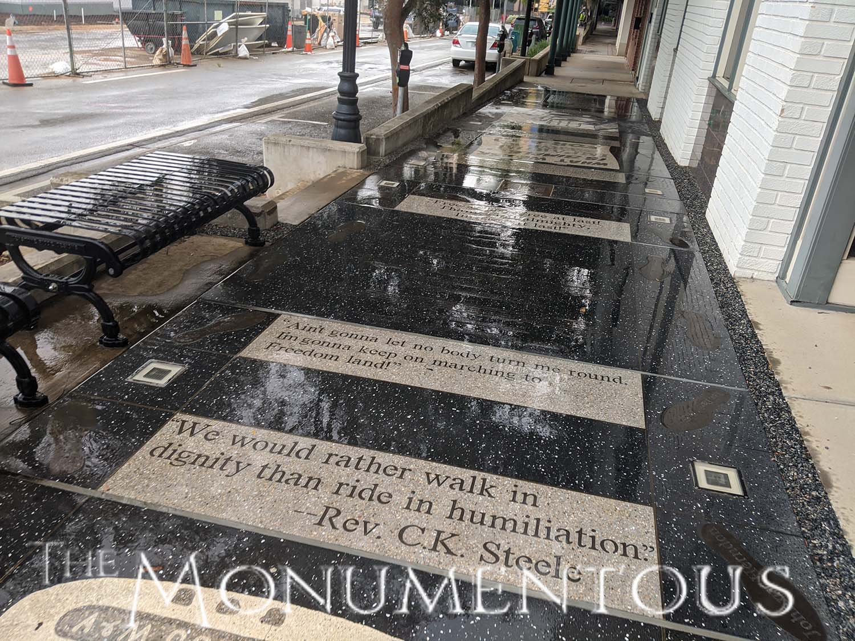

ATTACHMENT B
KEY TERM FRENZY

TALLAHASSEE BUS BOYCOTT
SIT-INS
REVEREND CHARLES KENZIE STEELE NAACP
PATRICIA STEPHENS
CONGRESS OF RACIAL EQUALITY (CORE)
NON-VIOLENT PROTEST
FLORIDA A&M UNIVERSITY
DR. MARTIN LUTHER KING
SOUTHERN CHRISTIAN LEADERSHIP CONFERENCE (SCLC)
WILHELMINA JAKES
CARRIE PATTERSON

ATTACHMENT C
KEY TERM FRENZY IMAGES
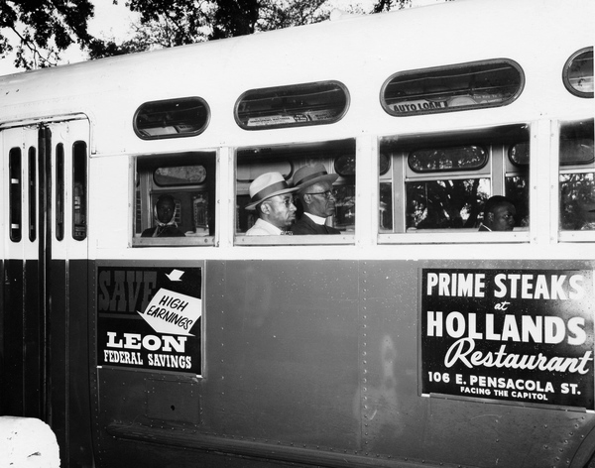
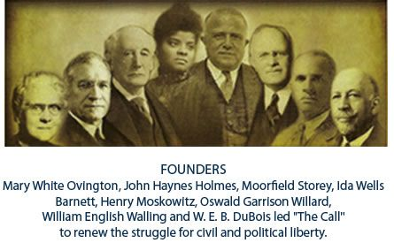

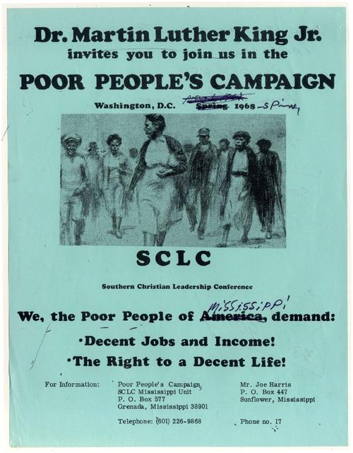
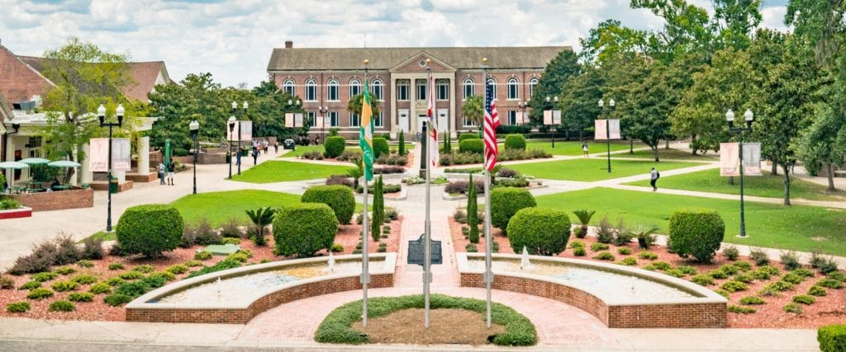
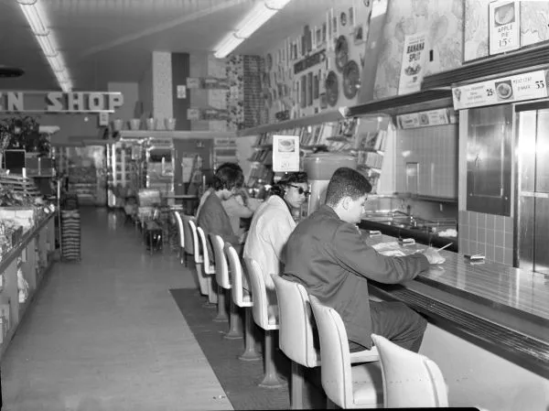

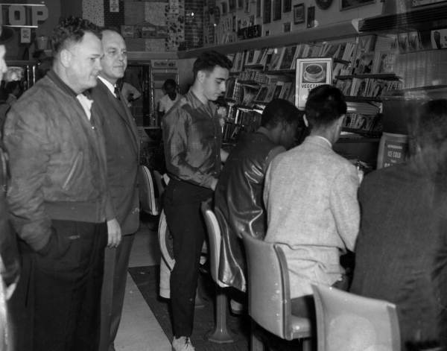
ATTACHMENT D
TALLAHASSEE WOOLWORTH SIT-IN
ATTACHMENT E
TALLAHASSEE CIVIL RIGHTS MOVEMENT QUESTIONS (AUDIO)

SOURCE: https://dunnhistory.com/story-tellers/#tallahassee-civil-cights-movement
LISTEN: Time 0:00-4:21 mins.

- In what year did the Tallahassee Civil Rights Movement start?

- Who led the Tallahassee Civil Rights Movement?

- According to the audio what is Tallahassee?

- What sparked the Bus Boycott Movement in Tallahassee, FL.?

- What colleges are located in Tallahassee, FL.?

- Why is Patricia Stephen considered an "Unsung Hero"?

- Who were the Tallahassee 11?

ATTACHMENT F
ST. AUGUSTINE, FL WHITES ONLY BEACH

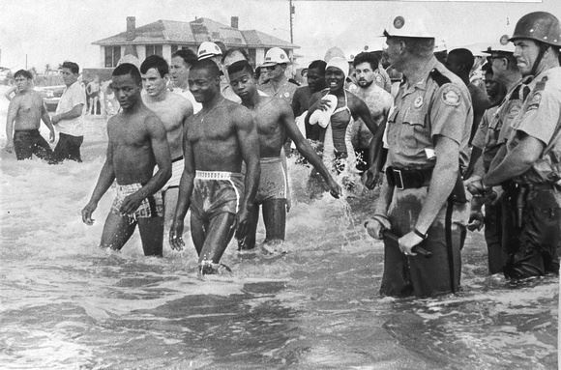

https://dunnhistory.com/media-gallery/

